**PROJECT TOPIC**

**Design and implementation of Real-time Obstacle Detection for the Visually Impaired: Integration of Infrared Sensors, Microcontroller, GSM, and GPS Technologies**

**Introduction:**

The number of blind and vision-impaired pedestrians who have had a collision or near collision with vehicles is increasing day by day. Therefore, I intend to provide a microcontroller-based solution which detects obstacle and alerts the user by means of vibration and when these people meet with accidents, the necessary people (family) or authorities can be warned using a SMS or call from their number without dialing by themselves.

**Objective:**

To improve the accuracy of obstacle detection by blind people “without tapping their guidance stick” on the ground and implement automated safety mechanisms

**Methodology:**

A block diagram was first created which consists of all necessary components and also indicating the flow of data and computing logic, later all the hardware components were procured and physical connection (wiring) was done. Then the source code which implements the computational logic was developed.

**Implementation:**

The infrared sensor would act like a closed switch when an obstacle comes close enough in its vicinity which would then be detected by the microcontroller and the vibration motor will be turned on and off (toggled) to indicate the direction of obstacle. If the user experiences an accident, then the vibration sensor would trigger the safety mechanism to make a call to the respective authority/family members.

**Software dependencies:**

* Arduino IDE
* Embedded C code

**Hardware dependencies:**

* NodeMCU
* UTP (Unshielded Twisted Pair Cable (Straight through)
* IR sensor
* Vibration sensor
* DC vibration motor
* SIM800L
* NEO - 6M GPS Module
* Mini breadboard
* 18650-battery, holder, case
* Light detection sensor
* White LED

**Advancements:**

* Usage of more IR sensors. More accurate obstacle detection
* Fully standalone device. No internet, Zero Cyber-threats (DOS)
* Automated accident detection
* Accurate location of the user using GPS
* Detect day or night and use strobe light to avoid accidents
* Fully automated GSM based alert zero human intervention

**Future work:**

Planning to integrate XIAO ESP32-S3 based camera module to capture and send images during an emergency situation based on a SOS button push from the user.

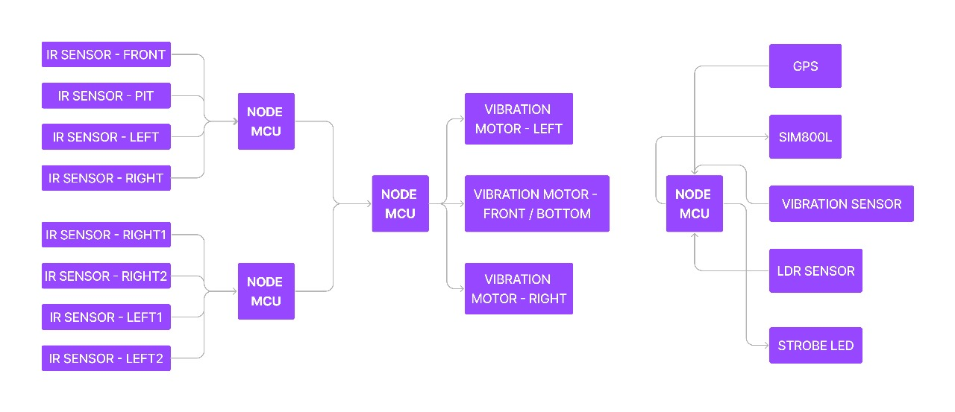**Block Diagram:**

**NOTE:**

This design, idea, logic, schematic, Gerber files and source code all are *copyrighted. Redistribution/ Reusing/ Modification is strictly prohibited.*

**REFERENCES:**

<https://www.researchgate.net/publication/356782700_IoT-Based_Smart_Blind_Stick>

<https://ieeexplore.ieee.org/document/9074374>

<https://ieeexplore.ieee.org/document/10010707>